To export saved passwords from Chrome (May 2025)

[1a] Copy and Paste this URL into your Chrome browser chrome://password-manager/settings
OR
[1b] From your browser, Click ‘Chrome’ to view SETTINGS,
then click on Autofill and Passwords
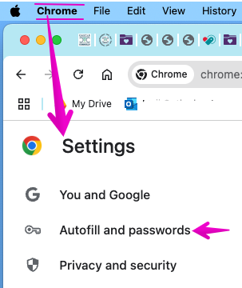

[2] Within the "Settings" section, locate "Export Passwords" and select "Download file" to save your passwords as a CSV file. [see screenshot below]
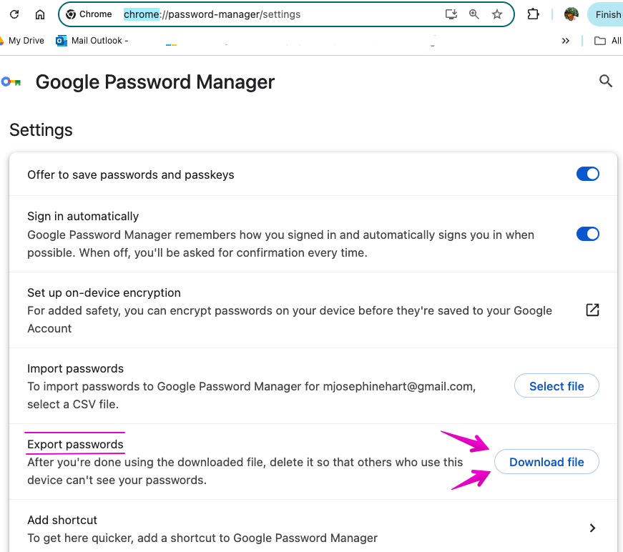

[3] When you click ‘Download File”, you'll be asked to enter your 'password' which will be your password that you use to login to your laptop.

[4] Next, you can ‘Export’ as a .csv or Excel document, save to your desktop etc. [see Screenshot
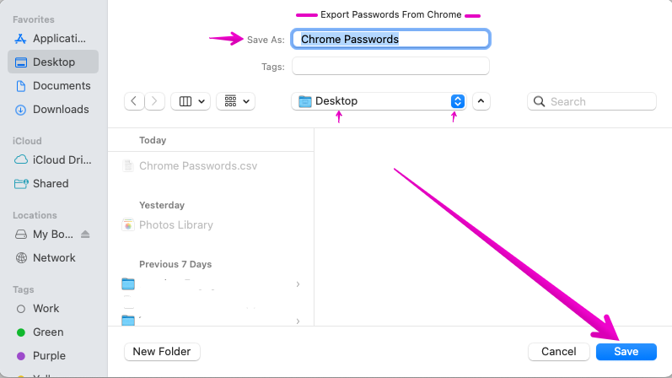

Click ‘SAVE”.
It is now in a “.CSV’ file format.

